Whitehaven and District Beekeepers Newsletter Summer 2014

Apiary News
It has been a very good spring and early summer for the bees at the Branch Apiary, with plenty of warm, sunny weather. The bees have increased well, and several nuclei have been made, for sale to members.
In general, there has been a strong tendency locally for bees to swarm this year, so most beekeepers now have better stocks of bees than in recent years.
On Sunday 25th May, a film crew who were filming for the Community Chanel (channel 63 on Freeview) visited the apiary to make a short documentary about the development of the apiary and garden. This part of a programme called “Brilliant Britain”, which visits community projects that have received lottery funding.
Val Sullivan was interviewed about the project, and then the crew filmed Richard going through one of the hives.
We don’t have a date for broadcast yet, but they will let us know in due course, and let us load the footage onto out website, so we will let you know.
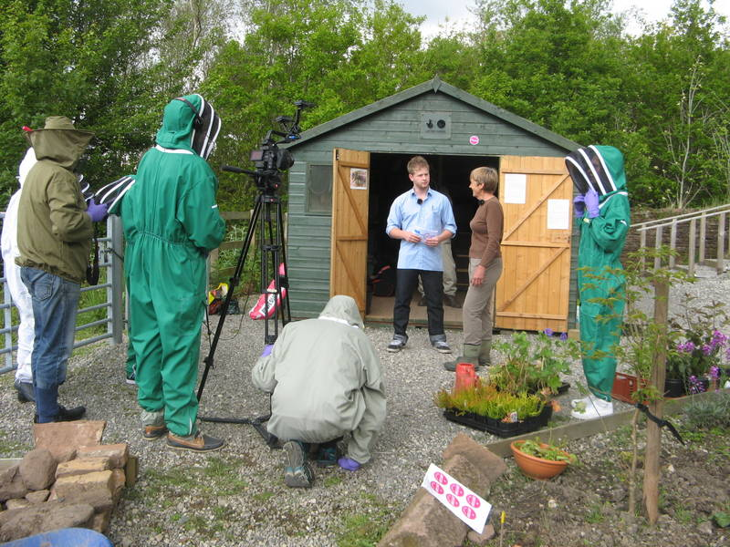
Just to remind everyone, our website is www.whitehavenbeekeepers.co.uk and if you want to access the “members only” section, the user name = member, and the password is WDBKA.
The apiary garden
The new garden is making good progress. Since the last newsletter in early April, the garden has been rotavated to break up areas of hard pan that had formed overwinter. (Thanks to Ian Nancollis for wrestling with the rotavator)
The raised bed in front of the hives has been planted with lots of herbs, and over 200 plants of Creeping Red Thyme have been put in to line the edges of the path.
The majority of the new plants are growing well, and the borage, nasturtiums and Red Thyme are looking very spectacular at the moment. One swarm of bees decided that the new trellis for the honeysuckle was the best place to cluster, but it proved fairly straightforward to transfer them into a nuc box.

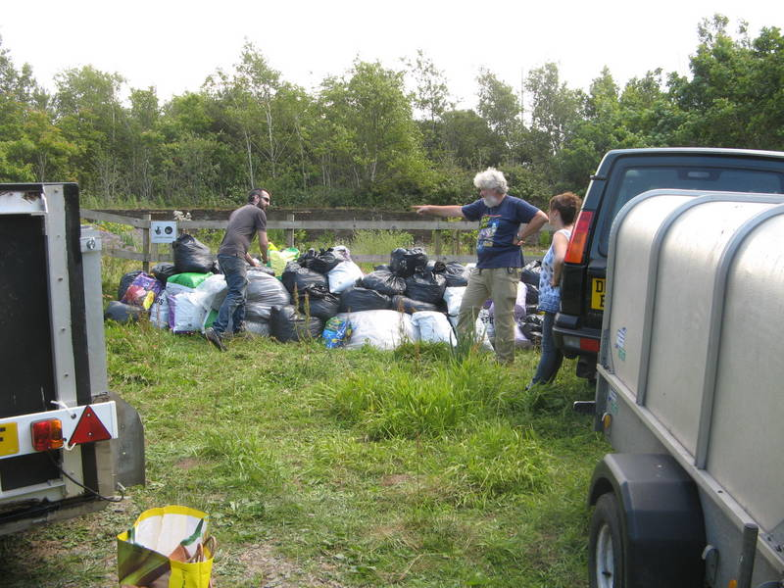
There is still plenty of weeding to be done, but a large amount of bark mulch is waiting at the apiary, to be spread as a weed suppressant. This was donated from Victoria Junior School in Workington, as they had a surplus from their garden project. Thanks to Helen for enabling this to happen, and to Paul and Ian for lots of shovelling. Also, thanks to the children who helped us to fill bags with the mulch.
Educational visits to the Apiary
On Monday 30th June, a group of Guides from Egremont came to visit the Apiary. Three hives were inspected, and in spite of some initial fears (including a genuine concern that bee-stings were always fatal), it was a very successful visit.
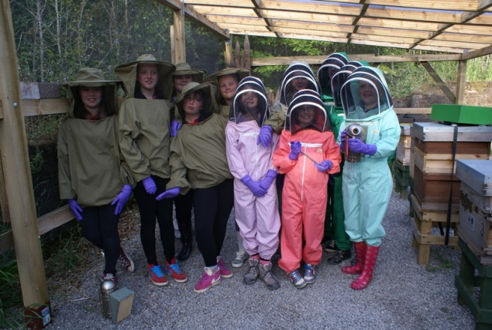
Further educational visits are planned this summer, from the Howgill Girls Group and some pupils from St Benedicts.
Dates for your Diary
Teaching Programme for July and August
There will be four teaching meetings at the branch apiary at Westlakes Science Park. On Sunday 27th July we will be joined by some of the beekeepers from the Cockermouth association.

Date Event
Saturday 19th July Teaching at Apiary
Sunday 27th July Teaching at Apiary
Sunday 10th August Teaching at Apiary
Monday 25th August Teaching at Apiary (Bank Holiday)

All meetings will start promptly at 13.00, please park in the overspill carpark at Westlakes

Whitehaven Beekeepers Annual Honey Show at Gosforth,on Saturday 16th August

This will be held on Saturday 16th August, in conjunction with Gosforth Agricultural Show. Val has sent some paper copies of the schedule, and an electronic copy of the full schedule is also attached. The entries for the Honey Show can be found on pages 11-13.
Each entry only costs 30p, and the closing date for entries is August 1st. Entry Forms can be downloaded from the show website at www.gosforthshow.co.uk and returned to;
Mrs A McKenzie, Fellside, Wellington, Gosforth, Seascale, Cumbria. CA20 1BJ

There are classes for jars of honey, a frame of honey ready for extraction and for beeswax.
There is a separate class for novices who haven’t won a prize for their honey previously, and if you don’t have any honey to exhibit, why not try baking a honey cake (recipes provided in the schedule) or making some confectionery with honey.
If you have children who are interested in bees, there are classes for them as well, for pictures, photos and designs for honey-jar labels.
It would great to have lots of entries, and make our Honey Show a real success. Lots of visitors come to Gosforth Show, so it is a real opportunity for us to showcase beekeeping in general, and our local beekeepers association in particular.
As part of this, Whitehaven Beekeepers will have a stand at the show, which will include the observation hive.

Cockermouth Beekeepers are holding their Autumn Convention at Embleton Village Hall on Saturday 13th September. The full programme is available via the Cumbria Beekeepers website, and there are some copies of their flyer at our apiary.

Library list

Dominic Rhodes has updated the list of beekeeping books that he has, following the donation of some additional titles by Fiona Galloway. Please see the separate attachment for details.
These are all available for members to borrow. If there are any which you are interested in, please contact Dominic at nic.rhodes@virgin.net

